Name_________________________________________ Date ______________________
Phone____________________ Email__________________________________________
Address for shipping____________________________________
____________________________________
Payment Method
Cash
Card
CashApp

Product/Course | Price | Units | Total
Grand Total

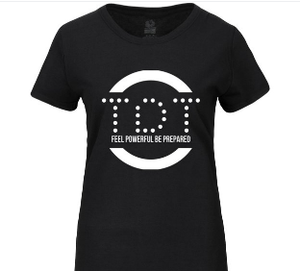
TDT 2 (no White)
TDT 3
PoP 1 (no White)
PoP 2 (no black)
TDT 1

